DeerCamp Legacy Collection – Dad’s Camp
- 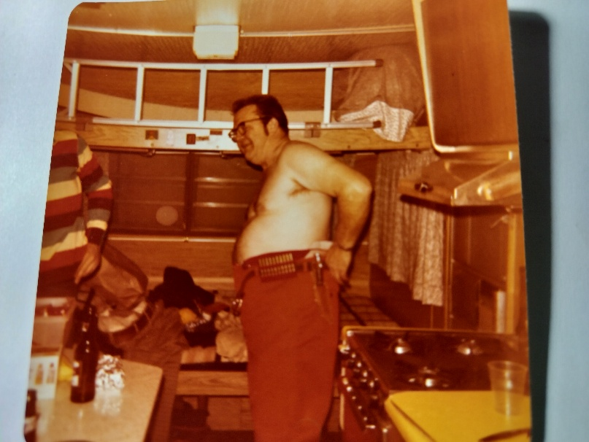
Neillsville, WI – Dad camping and hunting
- 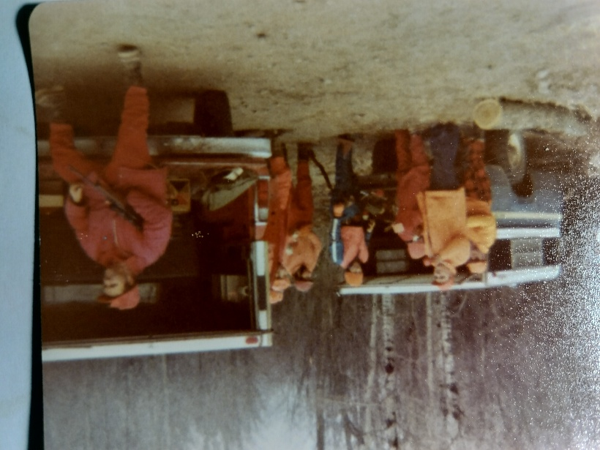
Cornell, WI – Dad organizing next deer drive

- 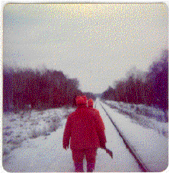
Neillsville, WI – Dad leading crew to #9

